**Purpose of this document** is to provide instruction on How to build, deploy and test this solution in your environment.

# Step 1

* Download the zip file
* <https://github.com/siddharth-vaghasia/SPFxWPConfigurableHeaderFooter>
* Extract to some folder

Step 2

* Open your project in any code editor(I prefer VS code)
* Rename package.json to have it as backup file, append ‘_bkp’.
* Rename package-lock.json to something else, append ‘_bkp’.

# Step 3

* Open node js command prompt
* Go to code path, make sure you see below files when ran ‘dir’ command.

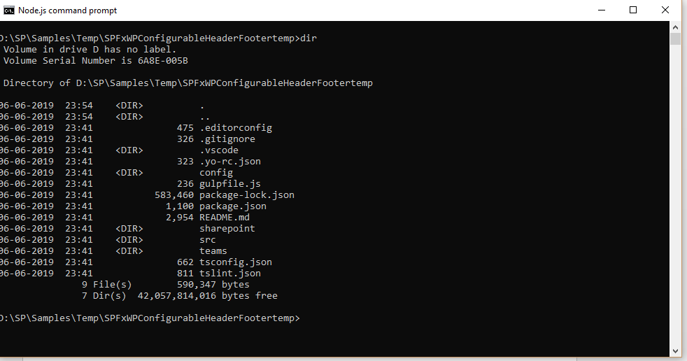

* Run **‘npm init --yes’** to create new package.json file

# Step 4

* Go back to Code editor, next we will copy **dependencies** and **devDependencies** attributes from our backup package_bkp.json to fresh created package.json

Below attributes for quick reference.

"dependencies": {

"@microsoft/decorators": "1.7.0",

"@microsoft/sp-application-base": "1.7.0",

"@microsoft/sp-core-library": "1.7.0",

"@microsoft/sp-dialog": "1.7.0",

"@microsoft/sp-lodash-subset": "1.7.0",

"@microsoft/sp-office-ui-fabric-core": "1.7.0",

"@microsoft/sp-webpart-base": "1.7.0",

"@types/bootstrap": "^4.3.0",

"@types/es6-promise": "0.0.33",

"@types/jquery": "^3.3.29",

"@types/sharepoint": "^2016.1.2",

"@types/webpack-env": "1.13.1",

"bootstrap": "^4.3.1",

"gulp": "^3.9.1",

"jquery": "^3.4.1"

},

"devDependencies": {

"@microsoft/sp-build-web": "1.7.0",

"@microsoft/sp-tslint-rules": "1.7.0",

"@microsoft/sp-module-interfaces": "1.7.0",

"@microsoft/sp-webpart-workbench": "1.7.0",

"@types/chai": "3.4.34",

"@types/mocha": "2.2.38",

"ajv": "~5.2.2"

},

"scripts": {

* Run **‘npm install’** to install all dependencies modules

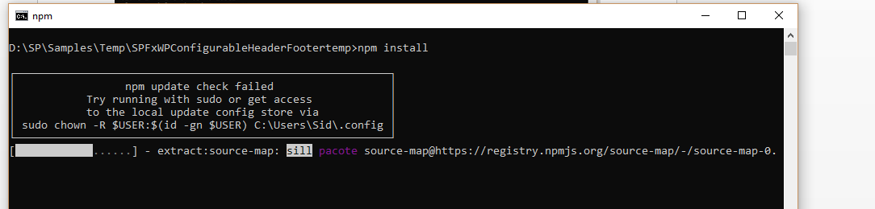

* It would run for some time, once installed you will see below message.

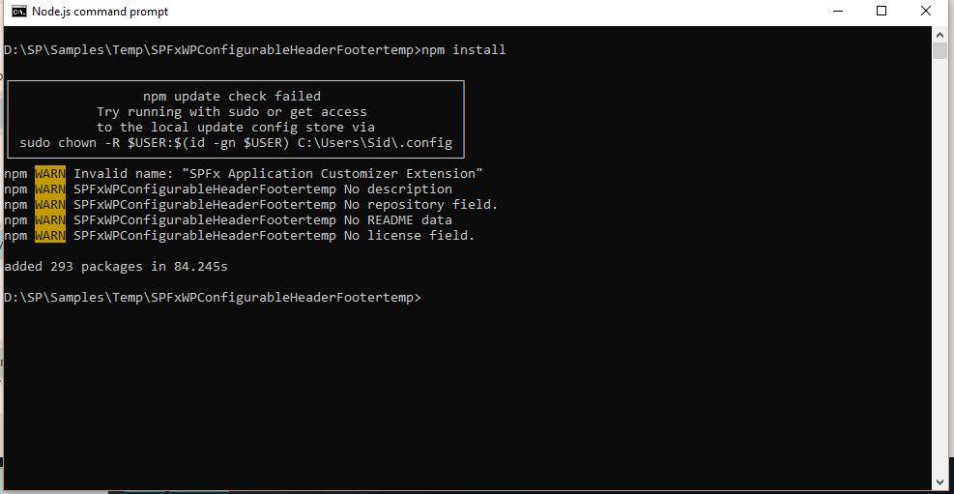

# Step 5

* Next step is to setup your serve.json to point to your environment for local testing.
* Go to **/config/serve.json**
* Update value of ***"pageUrl"*** to your site's page. Make sure this page exist in site, either you can create new page or use any of existing page link.

E.g. "pageUrl": "https://consoto.sharepoint.com/sites/mysc/SitePages/SFPxApplicationCustomizerExtension.aspx",

# Step 6

* Next step is to test on local enviorment.
* Go to Node JS command prompt
* run **'gulp serve'**
* If everything is setup correctly, It will open below a new browser page, and display below message, click on Load debug scripts.

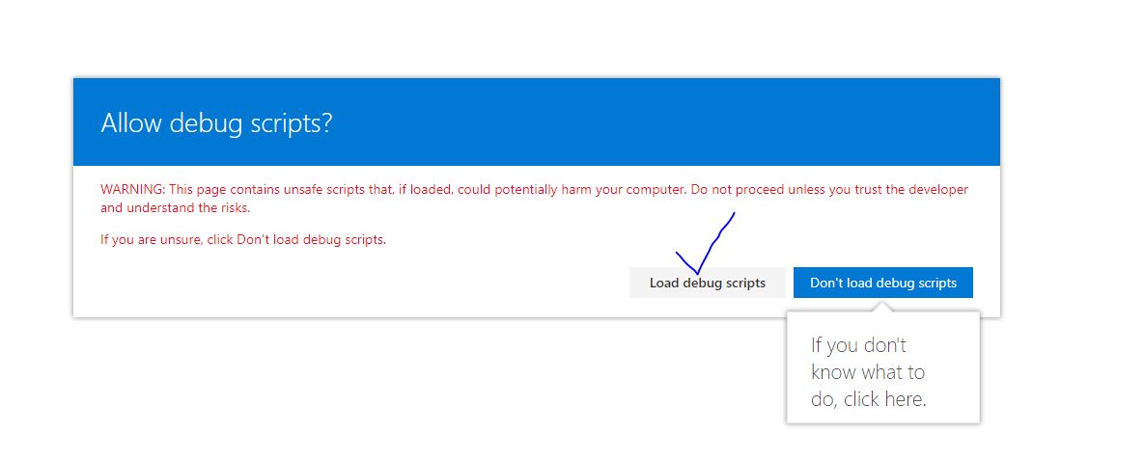

* Once you click on Load debug scripts, your page would open.
* Now let us Add our webpart.
* Click on Edit Page, add webpart name ‘WpConfigureApplicationCustomizerWebPart’

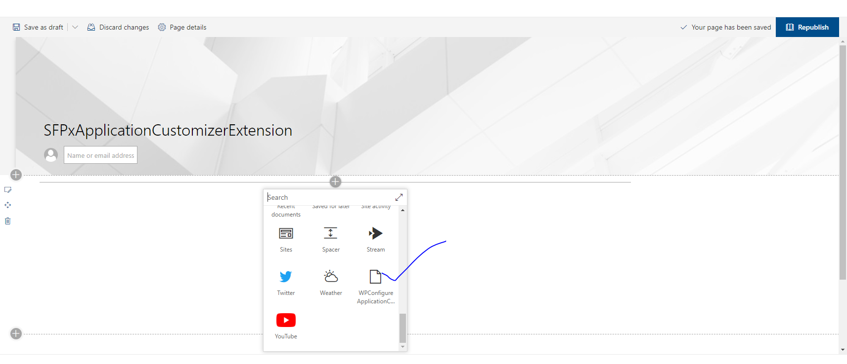

* It will open below page, add your Header and/or Footer html in text area

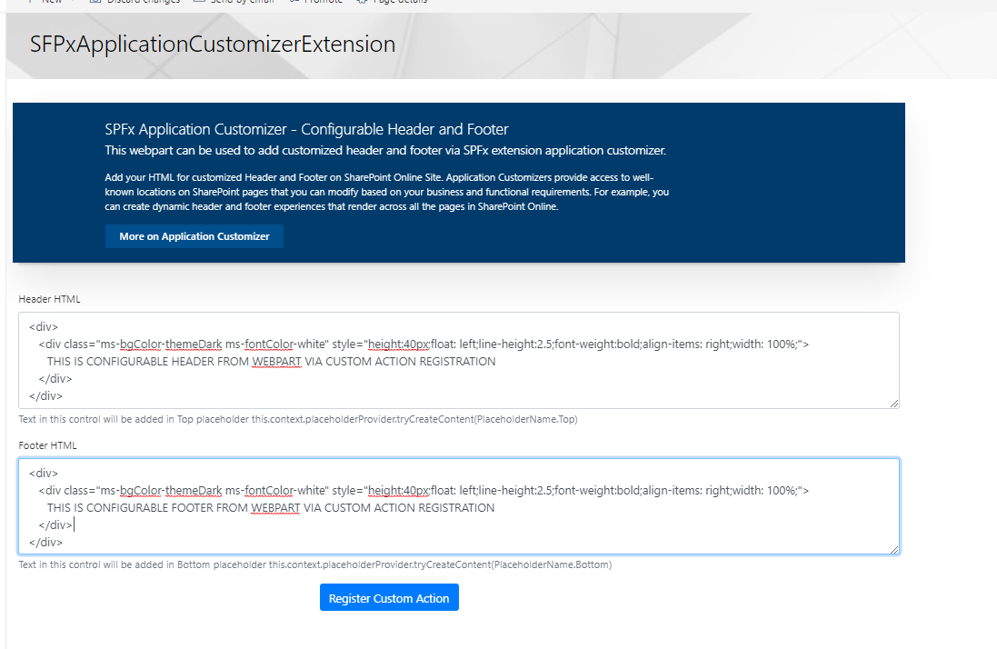

# Step 7

* Add custom HTML to either header/footer to text area.
* Click Register custom action, wait for success message.



* Refresh the page, you will see below header and footer inserted on page.

**HEADER**

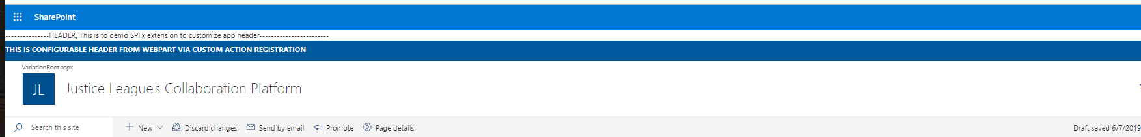

**FOOTER**



# Step 8

* Next we will see how you can edit Header or footer,
* If header and footer is already added before using this webpart and you visit the page
* Webpart would be loaded with header and footer text added before in text area.

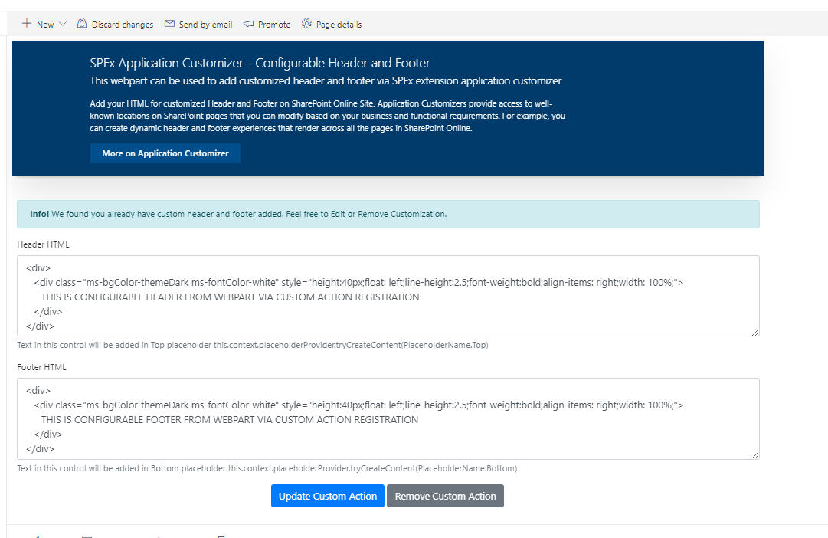

* Update HTML if required and click on Update custom action button. This will update header and footer.
* You can also remove custom action. This will completely remove header and footer from site.
* If you want only header or footer, you can add html to only respective text area and keep other one empty.

# Hope this solution will save your time an can be used as reusable component.

# Thanks

# Below are some issues which might come, and its solution. This will totally depend on environment.

Try running ‘gulp serve’, if you get below error ‘Local gulp not found….’

ran ‘npm install gulp@3.9.1’ command.

Please make sure you are install 3.9.1 only, gulp 4 is not supported yet for SPfx.

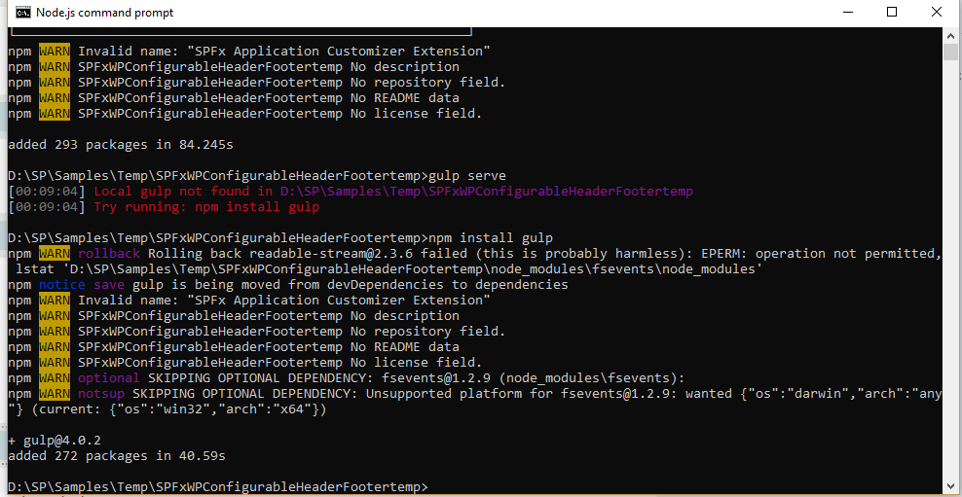

[00:30:55] Error - [spfx-serve] The api entry could not be loaded: node_modules/@microsoft/sp-webpart-workbench/lib/api/

[00:30:55] Error - [spfx-serve] Error: Invalid glob argument:

[00:30:55] Error - 'spfx-serve' sub task errored after 328 ms

**So ran ‘npm i @microsoft/sp-webpart-workbench’**

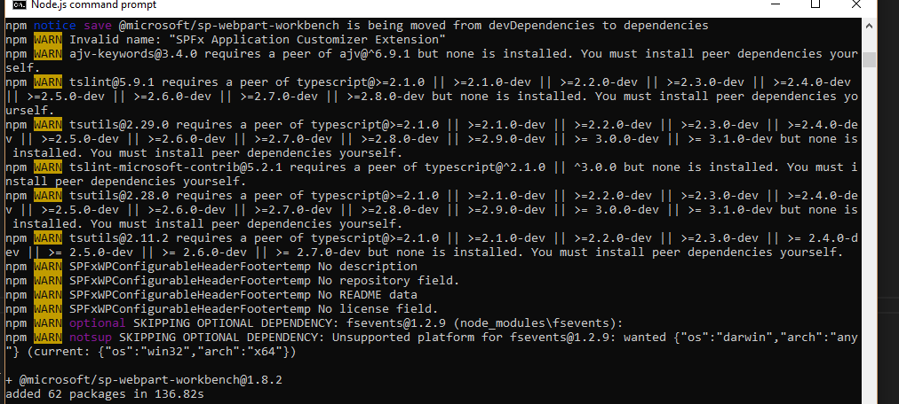

Try running gulp serve now,

For me I got error for ‘’ Error: Cannot find module '@microsoft/sp-build-web'”

So I ran “npm install --save-dev @microsoft/sp-build-web”

Then got below error

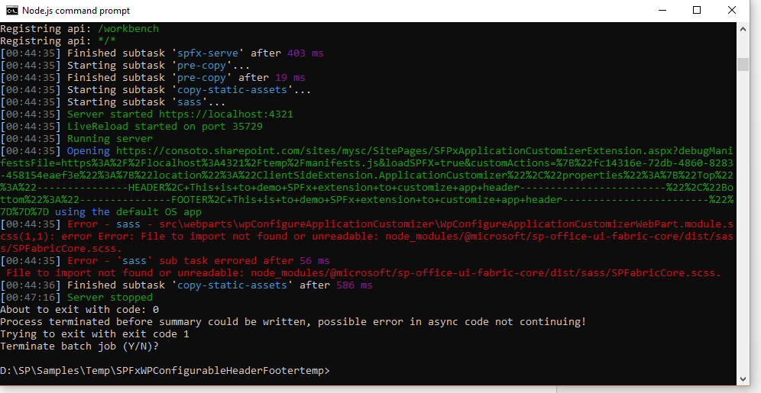

npm i @microsoft/sp-office-ui-fabric-core

After that below error

*[00:49:51] Error - [tslint] Error: Cannot find module '@microsoft/rush-stack-compiler-3.2'*

*[00:49:51] Error - 'tslint' sub task errored after 9.89 ms*

*Cannot find module '@microsoft/rush-stack-compiler-3.2'*

*[00:49:51] Starting subtask 'tsc'...*

*[00:49:51] Error - [tsc] Error: Cannot find module '@microsoft/rush-stack-compiler-3.2'*

*[00:49:51] Error - 'tsc' sub task errored after 4.55 ms*

*Cannot find module '@microsoft/rush-stack-compiler-3.2'*

**Error screenshot**

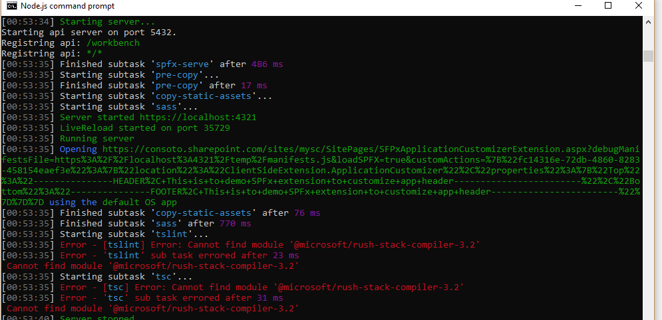

Ran npm i @microsoft/rush-stack

"pageUrl": "https://consoto.sharepoint.com/sites/mysc/SitePages/SFPxApplicationCustomizerExtension.aspx",